DERAM SERVICES SA

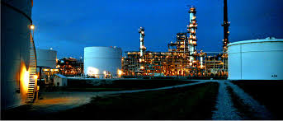

SIGMA CTRM

especially conceived for the

Collateral Management

of

Commodity Trading Companies

This documentation is strictly confidential and cannot be handed over to third parties
without the consent of DERAM SERVICES SA

SIGMA CTRM is conceived for the Treasury and Operations of commodity trading companies

Special emphasis is given to:

- Bank movements
- Bank positions
- Counterparty movements
- Counterparty positions
- Cash flow forecast
- Credits Lines usage
- Letter of Credits
- Physical book
- Daily/ monthly P&L
- Hedge Book
- Integrated workflow for authorization of payments of invoices
- Automated export of each movement to the accounting
- On-line tracking of physical movements (cargoes, trains)

Strategic choices for your Treasury / Operation department that will change your daily work
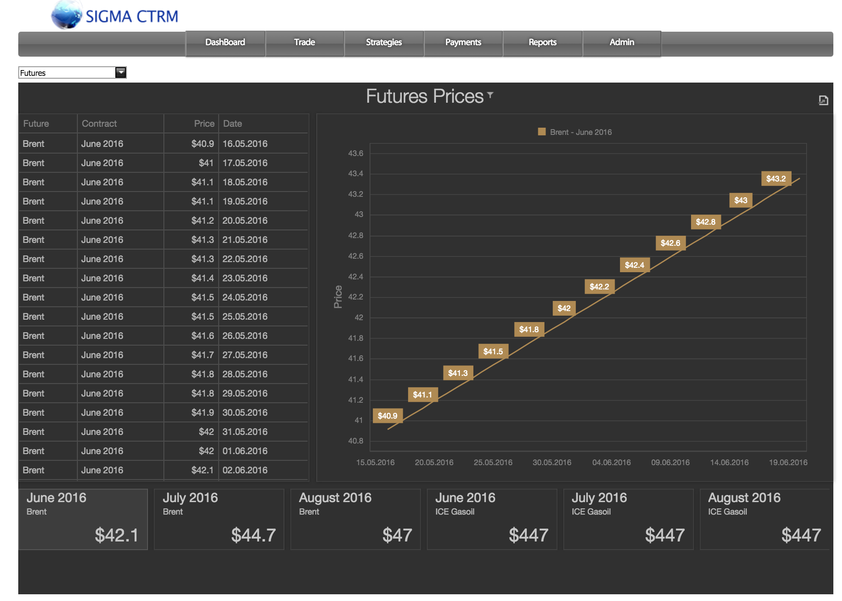

- Automated daily update of commodity prices, Futures and Forex

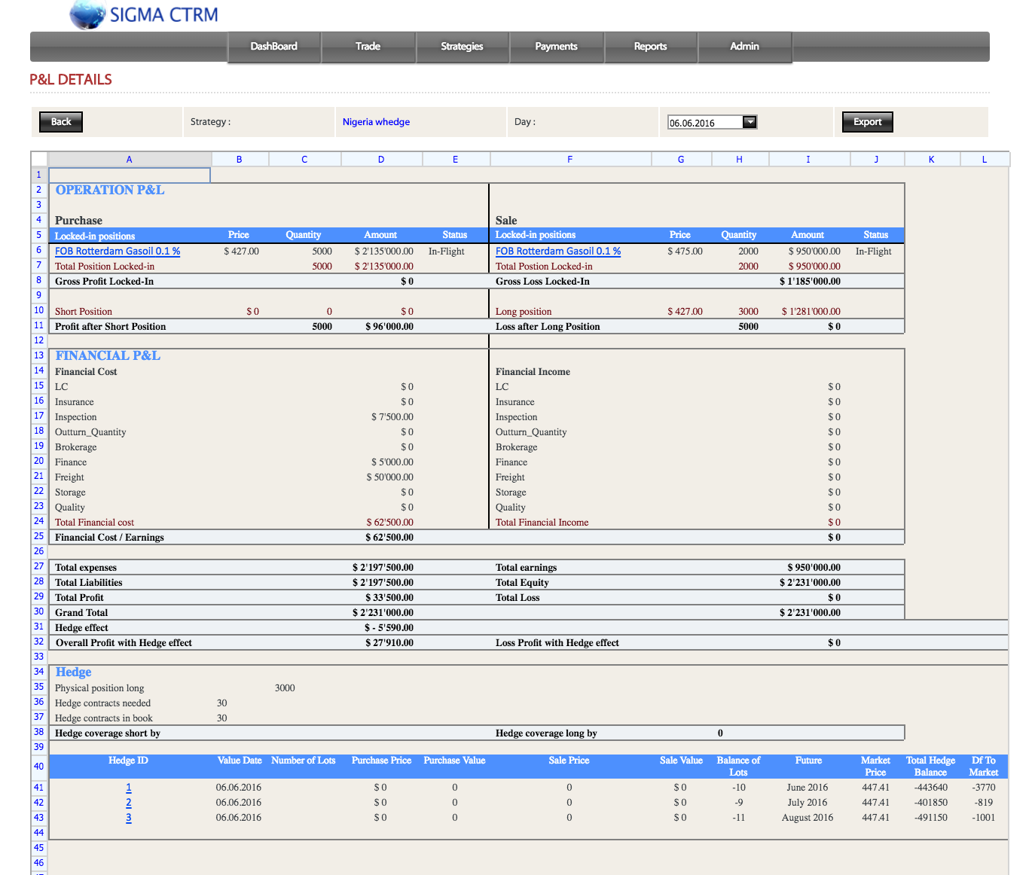

- Automated daily evaluation and P&L of each position “marked to market” with latest commodity and future prices integrating the associated hedge

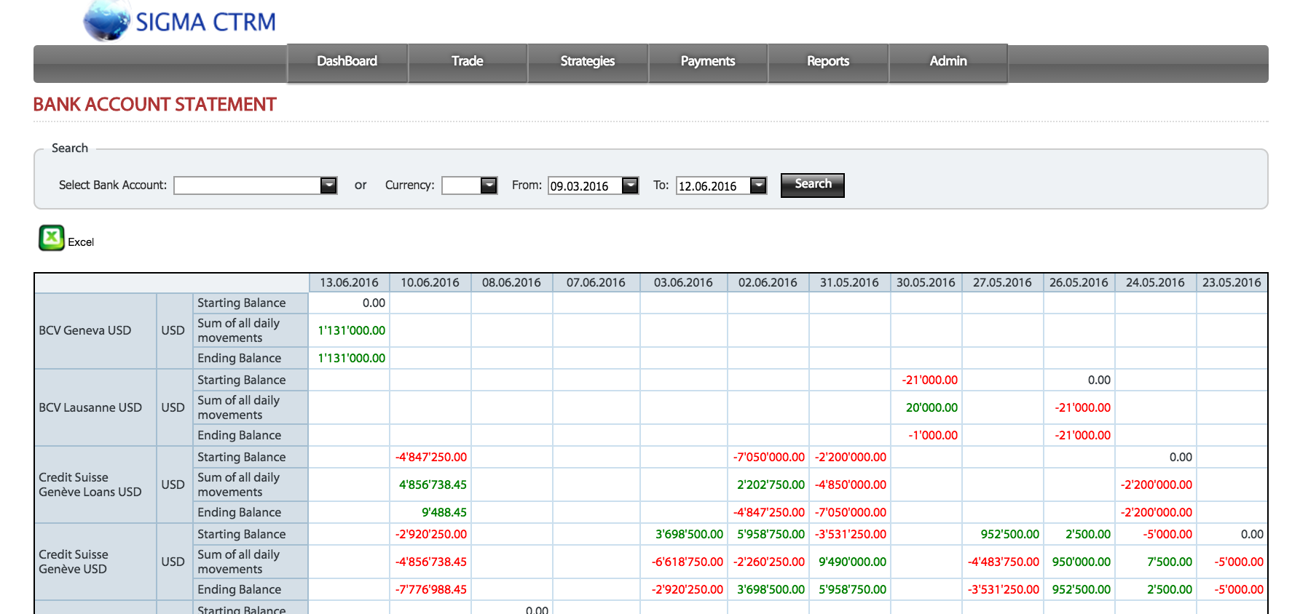

- Daily forecasts of cash flows associated with bank accounts

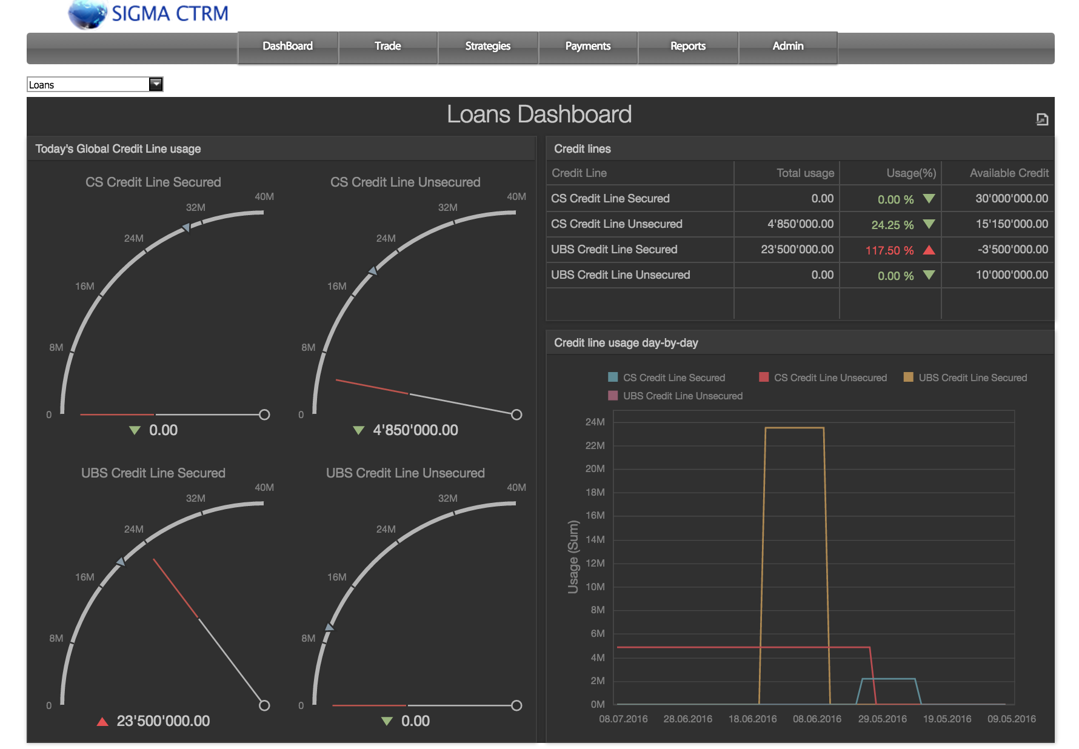

- Daily balances and credit line usages with banks and intercompany loans

- Handling of sub-credit lines

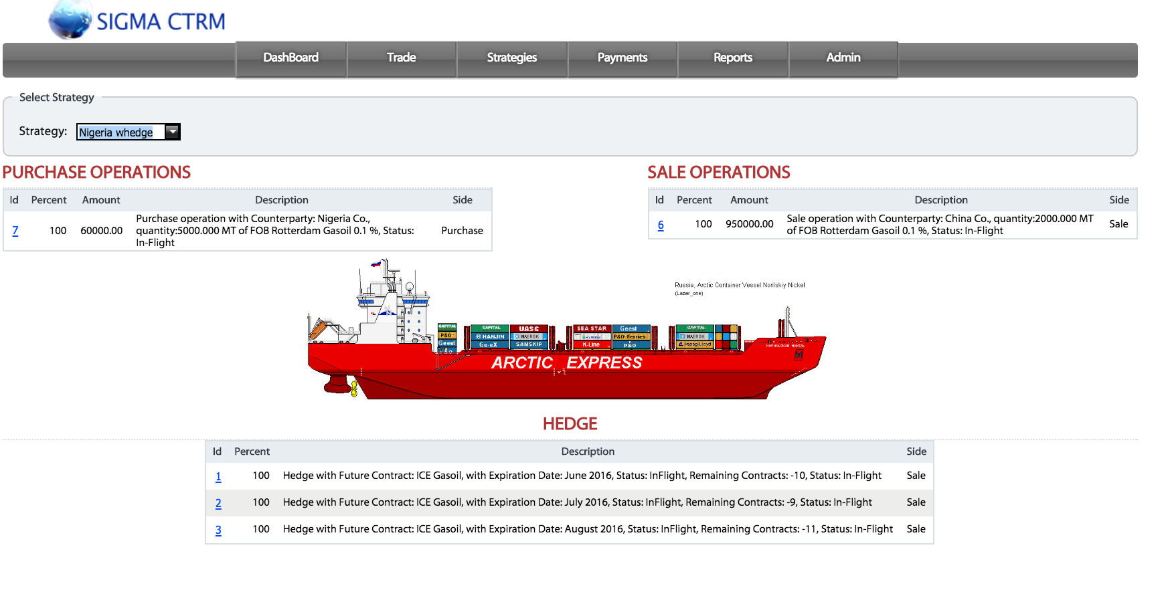

- Synopsis view on operations with purchase / sale operations and hedges

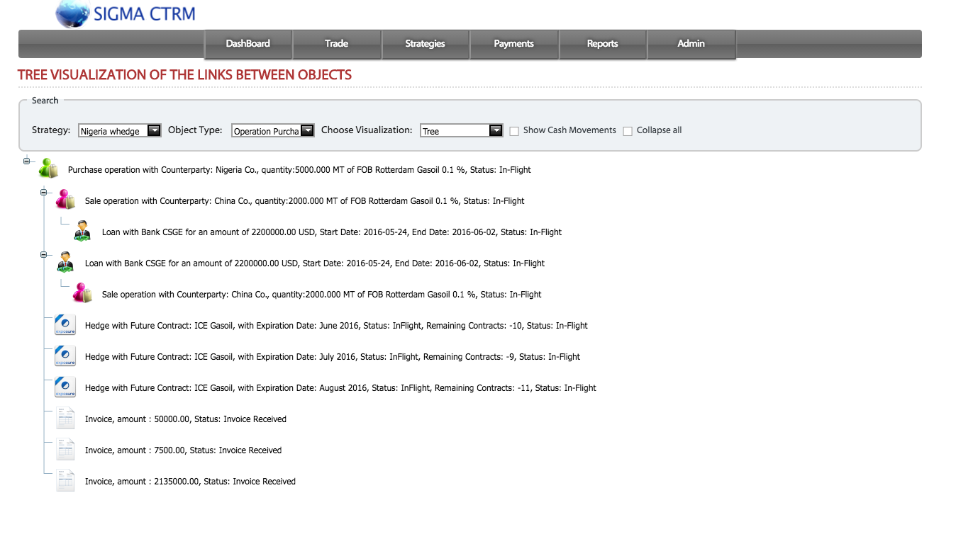
- Visualization of the whole trading operation with Deal sheet, Contract, Operation, Invoice, Loan, Hedge

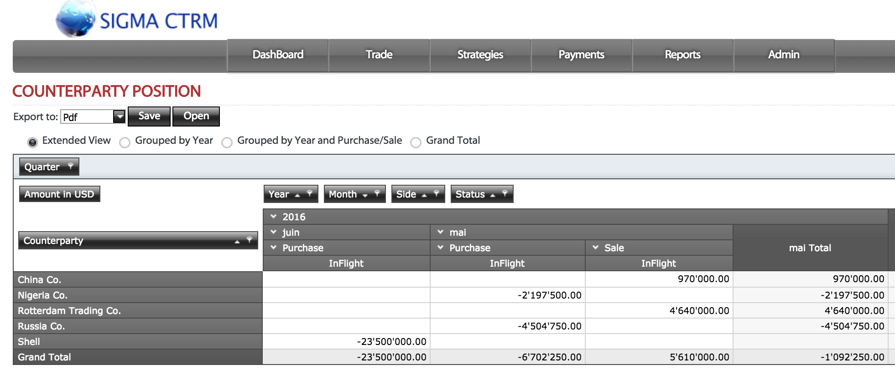

- Counterparty positions with flexible presentation and sorting

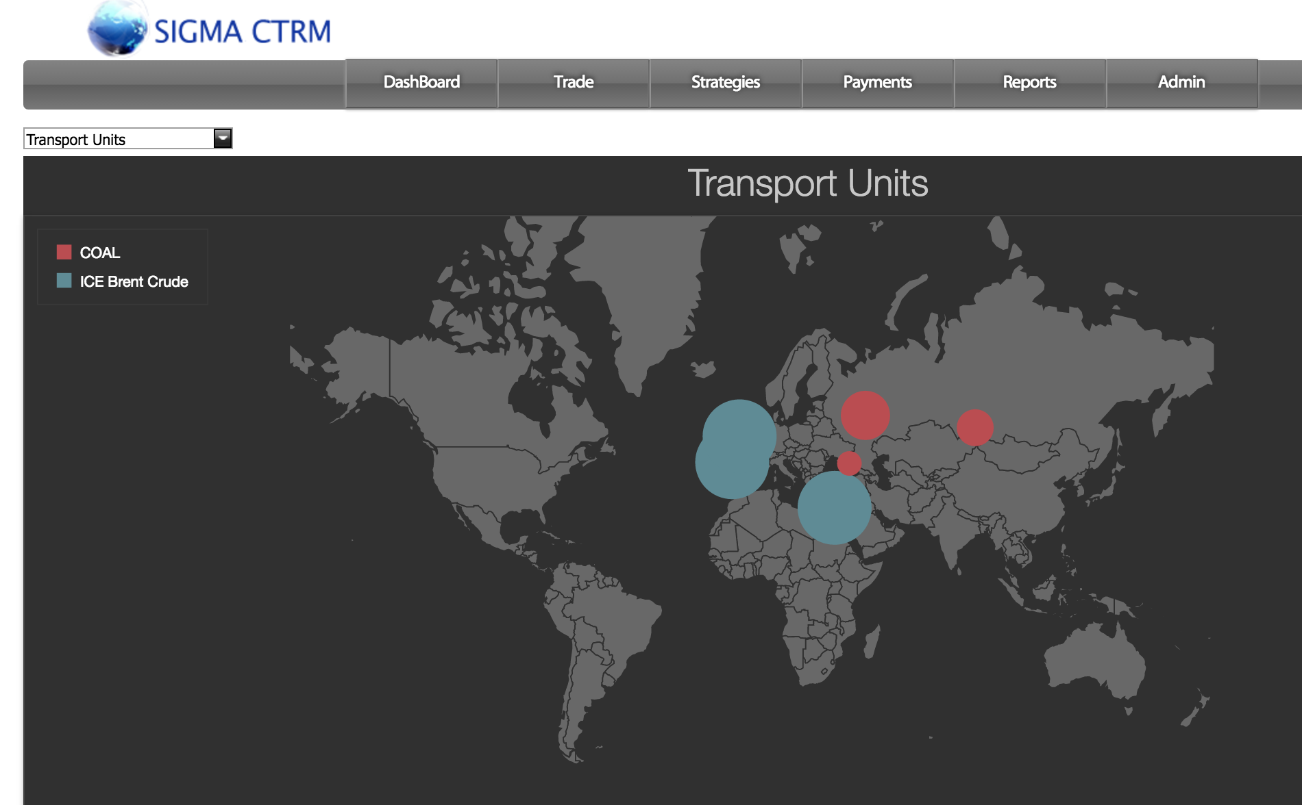

- Follow-up of physical position tracking of cargos, trains and trucks

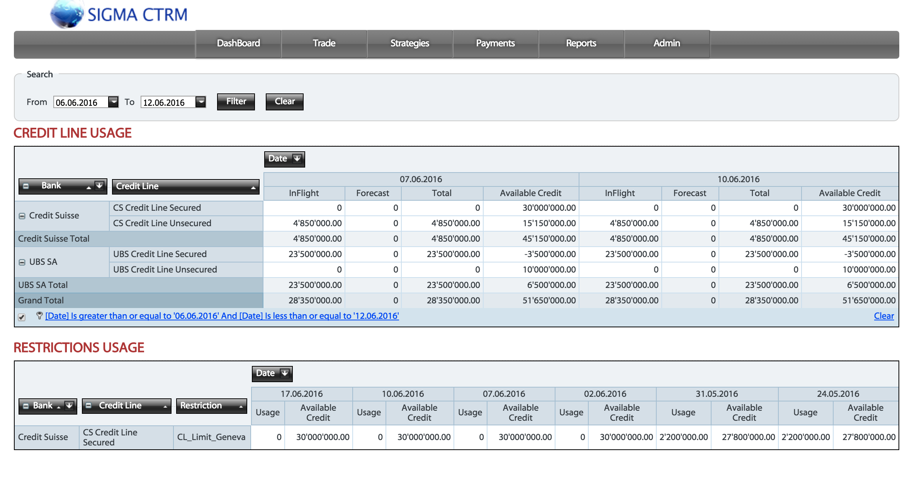

- View of credit Line and sub-credit line usage for banks and counterparties

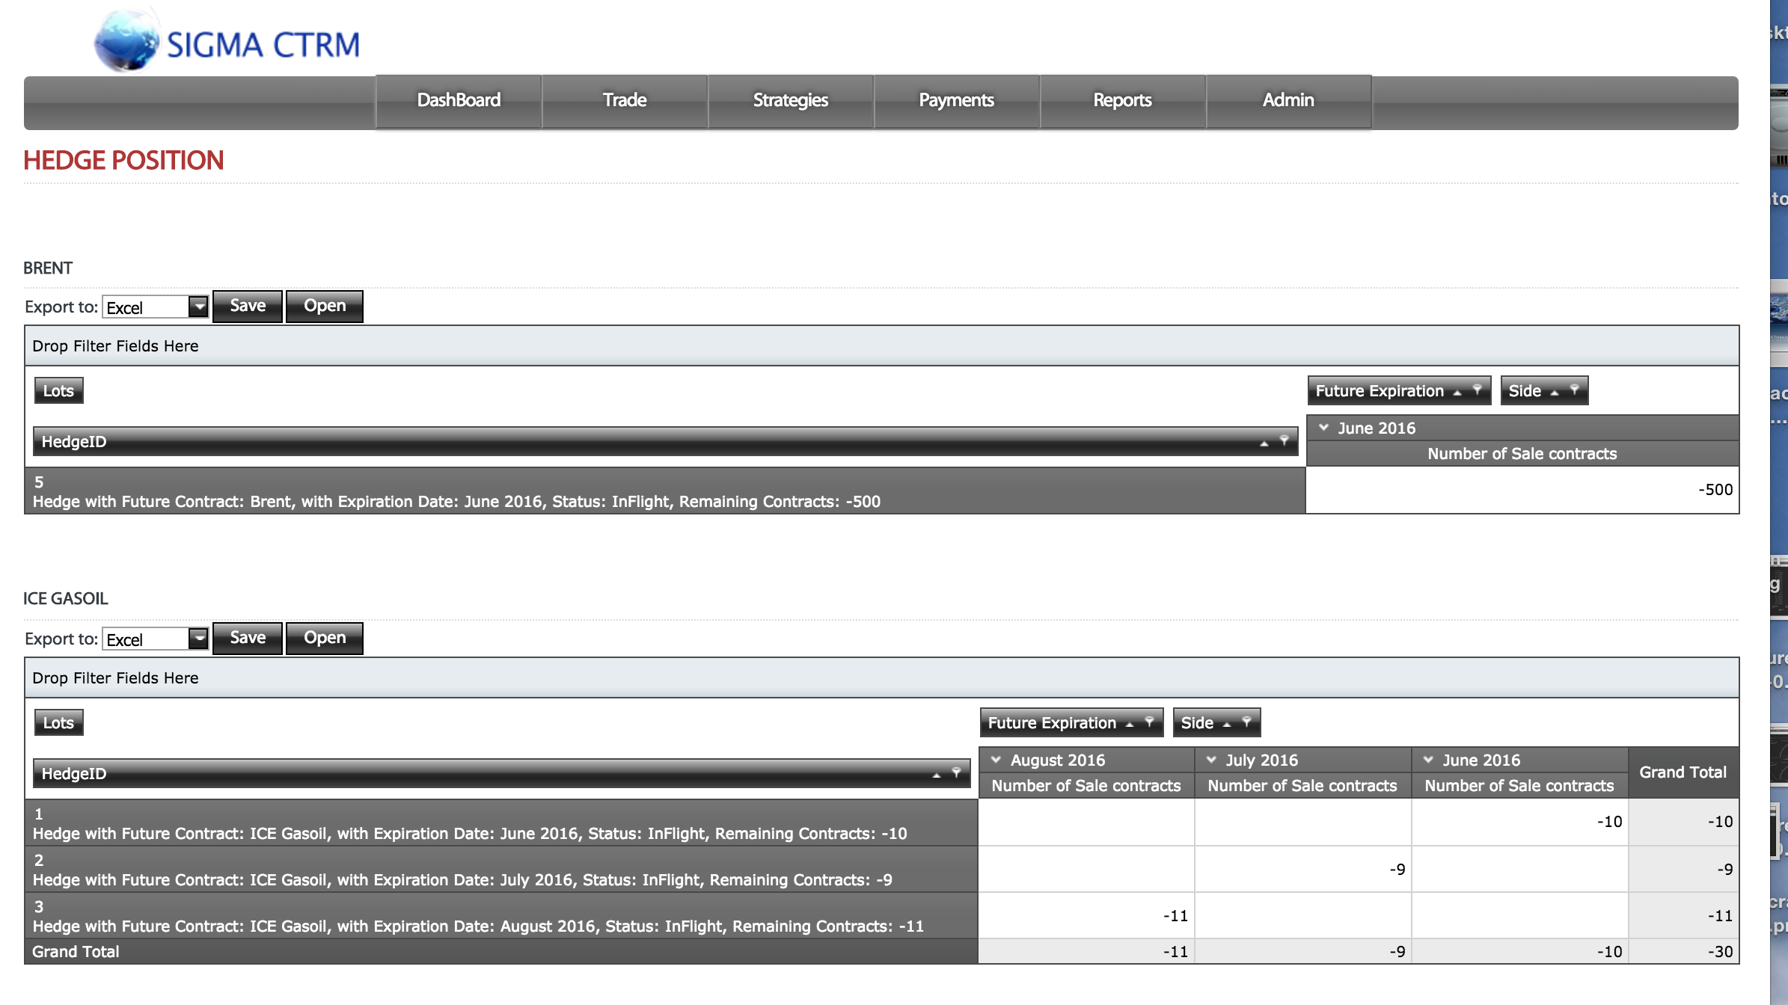

- Hedge book giving overview of each hedge sorted by type of future and future contracts, with drill-down possibilities to view details

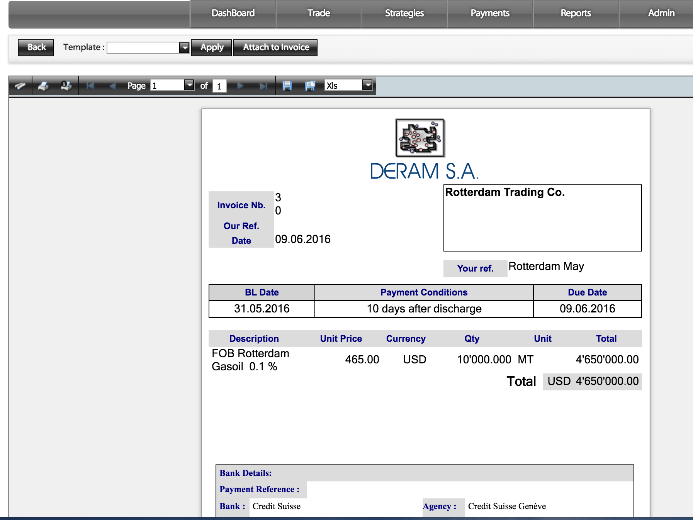

- Integrated workflow for invoicing and attachment of invoice with operation

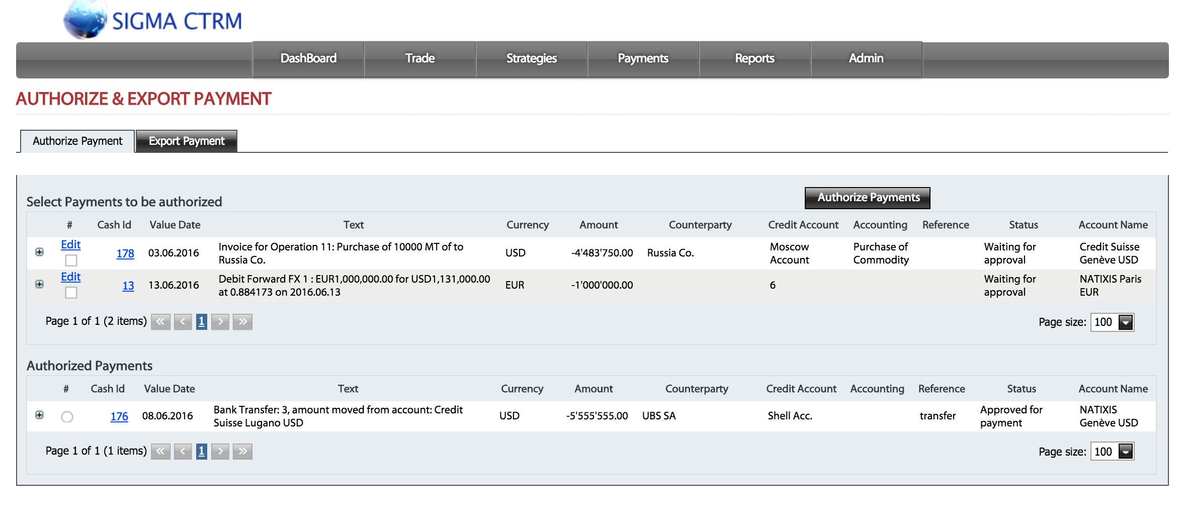

- Integrated workflow for authorization and execution of payments including reconciliation with bank account

Flexible and open for the future

- GUI’s for portable devices

- Can be interfaced with other systems

Automation and exception handling

- Automation of routine work
- Reminders and alerts for critical events
- Alerts for up-coming events
- Tracking of all interventions with audit trail

Customizable Reports

- Bank, Type of Credit Line, Cash
- Loans
- Counterparties
- Purchase / Sales operations
- Hedge Positions
- Report on cash / Loans
- Positions by bank
- Exception reports
- Reports for Audit

Secured information sharing

- Access via intra or internet
- Log-in control via passwords
- Multiple languages via Google Chrome translate feature

Supported Market Data Feeds
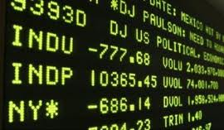
- Client defined feed handlers
- Interface with Platt’s on demand
- Excel sheet importer
- Connected to all stock exchanges world-wide via
  - Bloomberg Data License
  - Reuters DataScope Select
  - Telekurs VDF | IPS| VDF Flash

Easy transition to SIGMA Treasury

- Initial load of your legacy data into SIGMA
- Historic of all your data from day 1
- No installation on your desktop
- Help-Desk

For more information, please contact:

DERAM SERVICES SA

